**HEADING IN ENGLISH**

(Times New Roman, 14 pt., Bold, Center, All caps)

**Author(s) (names)**

**University / Institution**

**Е-mail**

(Times New Roman, 14 pt., Bold, Justified)

**Abstract:** abstract of the publication in English in volume up to 150 words

(Times New Roman, 12 pt., Bold, Justified)

**Key words:** the key words in English (from 3 то 6)

(Times New Roman, 12 pt., Justified)

**JEL:** (According http://ideas.repec.org/j/)

Here comes **the text of the publication**. (Times New Roman, 14 pt., Justified). The minimum volume of the publication is 12 pages and the maximum is up to 20 pages, including graphs, figures, tables and references. Citation must be in APA Style[1]. Font for the numbers and text in all tables, figures and graphs must be Times New Roman, 12 pt, Line spacing - Single. Formulas must be created with Equation Editor.

For example:

# **Tables**

Table 1: Frequencies of word classes

|  |  |  |  |  |
| --- | --- | --- | --- | --- |
|  | nouns | verbs | adjectives | adverbs |
| absolute | 12 | 34 | 23 | 13 |
| relative | 3.1 | 8.9 | 5.7 | 3.2 |

*Source: …………*

# **Figures**

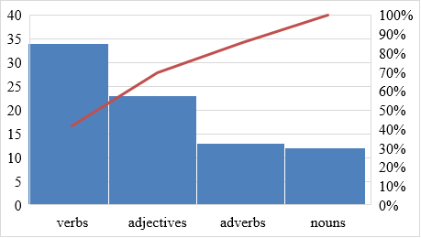

Fig. 1: Frequencies of word classes

*Source: …………*

At the end you have to provide **References** (Times New Roman, 12 pt., Justified).

For example:

# **References**

Cândido, C.J.F. and S.P. Santos (2015) Strategy implementation: What is the failure rate? *Journal of Management & Organization*,21(2),237-262. DOI: <http://dx.doi.org/10.1017/jmo.2014.77>

Fredrickson, J.W. and Iaquinto, A.L. (1989). Inertia and creeping rationality in strategic decision processes. *Academy of Management Journal*, 32(3), 516-542.

Vanden Wyngaerd, Guido. 2017. Forest quickstart guide. <https://linng.auf.net/lingbuzz>

The end of the article provides **brief information about each author** (4-5 lines), incl. academic position, The author's ID number in the scientific baseс is provided in a new line.

For example:

Plamen M. Pavlov is Head Assistant Professor, Doctor of Economics in the Department of Industrial Business, University of Economics - Varna, Bulgaria.

ORCID ID: 0000-0003-4234-8016

1. When citing sources, authors should observe the requirements of **APA Style** at <http://www.apastyle.org/> **or at** <http://owl.english.purdue.edu/owl/resource/560/01/>