ЗАГЛАВИЕ НА ДОКЛАДА (Times New Roman, 16pt, удебелено, центрирано, главни букви)

Академична длъжност, научна степен, име и фамилия на автора (Times New Roman, 16 pt., удебелено, центрирано, с бележка под линия се посочва email адрес и организация/институция на автора, при доклад в съавторство всеки автор се изписва на отделен ред със същото стилово оформление и без разстояние между редовете)
Резюме: резюме на български език до 350 символа (Times New Roman, 12 pt., курсив, двустранно подравняване)

Ключови думи: между 4 и 6 ключови думи (Times New Roman, 12 pt., курсив, двустранно подравняване)

JEL: JEL кодове (Times New Roman, 12 pt., удебелен, двустранно подравняване)

MANUSCRIPT TITLE IN ENGLISH (Times New Roman, 16 pt., bold, centered, all capitals)

Academic rank, Scientific degree, Author’s Full Name (Times New Roman, 16 pt., bold, centered. In the case of a co-authored paper, each author should be listed on a separate line, using the same formatting style and without extra spacing between the lines.)

Abstract: abstract in English up to 350 characters (Times New Roman, 12 pt., italic, justified)

Keywords: from 4 to 6 words (Times New Roman, 12 pt., italic, justified)

JEL: JEL codes (Times New Roman, 12 pt., bold, justified)

- Introduction (Times New Roman, 14 pt., bold, left alignment)
Introduction text (Times New Roman, 14 pt., justified).

- Paragraph One title (Times New Roman, 14 pt., bold, left alignment)
Paragraph One text (Times New Roman, 14 pt., justified). All figures, (charts, diagrams, pictures, etc.) should be formatted using the Wrap Text feature In Line with Text. Their titles should be placed below the figure, numbered consecutively. The source shall be cited below the title.

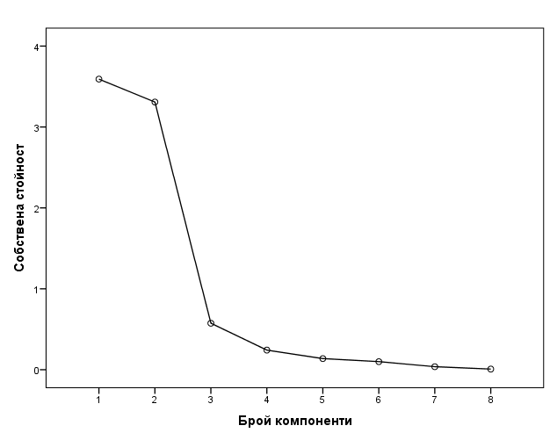
Figure. 1. Title (Times New Roman, 14 pt., italic, centered)
Source: www.nsi.bg (Times New Roman, 12 pt., italic, centered)

All references must be cited using the APA Style format (https://www.uni-svishtov.bg/bg/research/papers/iziskvaniya-za-bibliografsko-tsitirane).
Additional notes, explanations, and comments should be provided as footnotes.

  - Subparagraph One title (Times New Roman, 14 pt., italic, left alignment)
Subparagraph One text (Times New Roman, 14 pt., justified).
For all tables containing data, a sequential number and title of the table should be placed above the table. The source shall be cited below the table.

Table 1. Number of startups in the sector Information and Creative Products Creation and Dissemination (Times New Roman, 14 pt., italic, left alignment)
Type | 2017 | 2018
Limited liability companies and joint stock companies | 1898 | 1974
Partnerships and other legal forms | 33 | 59
Source: NSI (Times New Roman, 12 pt., italic, left alignment)

Use Times New Roman, 12 pt., regular front for the data in the table and bold font for the table header. The table should be centered relative to the main text in the paragraph/subparagraph.

  - Subparagraph Two title (Times New Roman, 14 pt., italic, left alignment)
Subparagraph Two text (Times New Roman, 14 pt., justified). The number of paragraphs and subparagraphs (if any) in the paper is determined at the author’s discretion.

- Paragraph Two title (Times New Roman, 14 pt., bold, left alignment)
Paragraph Two text (Times New Roman, 14 pt., justified).
Formula numbers should be indicated with a numeral, placed to the right of the formula, in parentheses.
(1)

- Conclusion (Times New Roman, 14 pt., bold, left alignment)
Conclusion text (Times New Roman, 14 pt., justified).

References (Times New Roman, 14 pt., bold, left alignment)
The list of cited references should be formatted according to the requirements of APA Style (Beins, 2012). The references should be arranged in alphabetical order, with those in Cyrillic listed first. (Times New Roman, 14 pt., left alignment).

Богданова, М. (2020). Университетските бизнес модели при управление на кризи. Бизнес управление(4), 37-48.
Beins, B. (2012). APA Style Simplified: Writing in Psychology, Education, Nursing, and Sociology. New York: Wiley-Blackwell.

Author’s E-mail and organization/institution (Times New Roman, 12 pt., justified, single spacing)
Additional notes, explanations, and comments (Times New Roman, 12 pt., justified, single spacing).

