Odessa Regional Institute
for Public Administration
of the National Academy
for Public Administration
under the President of Ukraine
Management of Organizations Chair
Students’ Self-Government

XXI Annual International and Ukrainian, theoretical and practical conference for students:

“Modern Management:
Models, Strategies, Technologies”

23 April, 2020

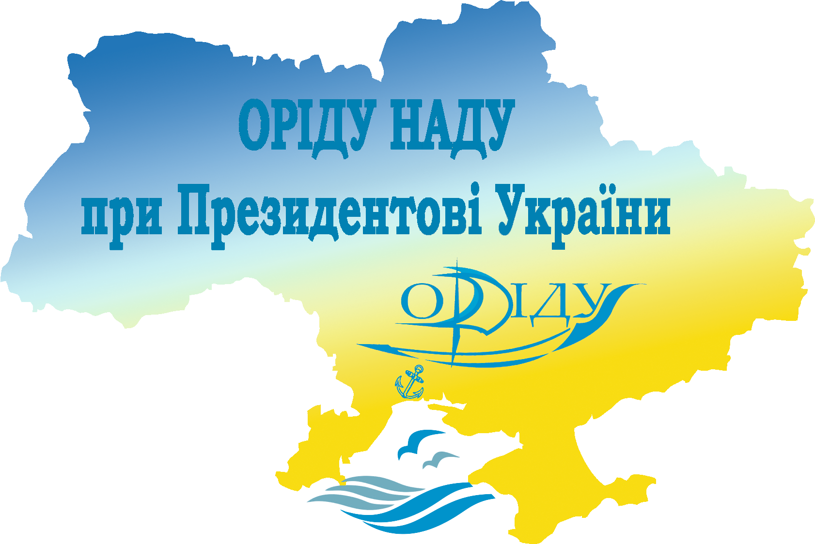

Odesa
DEAR COLLEAGUES!

We invite postgraduate, master and bachelor students to take part in the XXI Annual International and Ukrainian, theoretical and practical conference for students: “Modern Management: Models, Strategies, Technologies”, which will be held on April 23, 2020 in the Odessa Regional Institute for Public Administration of the National Academy for Public Administration under the President of Ukraine: Odesa, 22 Genuezka str., room 401

THE ORGANIZING COMMITTEE
N. Krasnostanova — chairman, head of Management of Organizations Chair.
I. Kusplyak - co-chairman, dean of Public Management and Administering Faculty.
V. Vishnevska — co-chairman, acting dean of Management and Business Technologies Faculty.
S. Maidaniuk — secretary, associate professor of Management of Organizations Chair.
Organizing Committee Members:
T. Bezverkhniuk, Head of Project Management Chair.
N. Kolisnichenko, Head of Ukrainian and Foreign Languages Chair.
Yu. Pigariev, Head of E-Government and Information Systems Chair.
T. Pakhomova, Head of Regional Policy and Public Administering Chair.
V. Pushkar, the 4th year student of the specialty “Management” of Management and Business Technologies Faculty.
U. Kapral, the 2nd year student of the specialty “Management” of Management and Business Technologies Faculty.
S. Zadorozhnij, the 4th year student of the specialty “Management” of Management and Business Technologies Faculty.
D. Chupryna, the 1st year student of Public Management and Administering Faculty.
CONFERENCE SECTIONS

- Management of Innovative and Investment Activity of Organizations
- Strategic Management and Marketing
- Global Trends in Management Development
- Project Management: Evolution of Technologies
- New Insights into Management (working language — English)
- Digital Technologies in Management
- Public Management and Administering

The conference working languages are: Ukrainian and English.

Form of participation: plenary report, section report, publication without report. All forms of participation are FREE.

Requirements for participation: Participants should send application forms and abstracts to the conference mailbox (application form sample and abstract requirements are attached) NOT LATER THAN MARCH 31, 2020.

The conference collection: the abstracts are going to be published in the Conference collection. Everyone will be able to download a PDF-file of abstracts on the institute web-site for FREE. A paper copy of the Conference collection can be purchased for cash at the Conference.

Travel and accommodation expenses are covered by participants. At the reservation preliminary approved by the organizing committee, a place in the students’ dormitory is available.

REQUIREMENTS FOR CONFERENCE ABSTRACTS PRESENTATION:

- Abstracts should be written in Microsoft Word, type of file “Document Word 97-2003 (*.doc)”.
- All margins — 2 cm.
- Print Times New Roman, print size — 14; line spacing 1; indentation — 1,25 сm; text alignment — full justification.
- Tables should be done in Microsoft Word. Title of the table should be printed above in centre and the illustrations — in centre below.
- Volume is: 2 (two) FULL pages in А-4 format.
- The Bibliography should contain EXCLUSIVELY the sources for which there is a link in the text (example of the Bibliography design — “quote” [3, p. 324]).
- The bibliographic reference is made in accordance with the norms of DSTU 8302: 2015 “Bibliographic reference. General Terms and Rules for Composition”.
- Abstracts, containing plagiarism, will not be considered.
- Materials which are not written according to the requirements or/and are presented after March 31 will not be considered.
- The editorial committee of the conference has the right to edit the abstract text.
- The title of the abstract and application file must consist of the surname, initials and the words “abstract” or “application”, the file name must be in the same language as the abstract text, for example, “Sirko_I_D_abstact.doc”, “Sirko_I_D_application.doc”.

ABSTRACT EXAMPLE

M. Melnyk
student of __________
__________________
Scientific Advisor:
Prof., Ph.D. S. Jaromich

ABSTRACT TITLE

text text text text text text text text text text text text “quote” [3, p. 324]. …

Bibliography
1.
2.
3.

Participants’ applications and abstracts are accepted from February 01, 2020 to March 31, 2020 at the e-mail: konf.origu@gmail.com.

The conference is held at: room 401, 22, Genuezka str., Odessa, 65009, Ukraine. Participants’ registration starts at 9:00 a.m. The Conference starts at 10:00 a.m.

For more information, please, contact: e-mail: konf.origu@gmail.com, tel.: (+38) 0-66-002-65-97 — Chairman of the Committee for Research, International and Inter-University Relations of Student Self-Government Ms. Ulyana Kapral.

APPLICATION FORM
for the participant of the XXI Annual International and Ukrainian,
theoretical and practical conference for students::
“Modern Management:
Models, Strategies, Technologies”

Surname __________________________________
Name _____________________________________
Patronymic ________________________________
Educational Institution _______________________
__________________________________________
Abstract title _______________________________
__________________________________________
__________________________________________
Surname / Name / Patronymic and scientific degree of the Scientific Advisor ______________________
__________________________________________
__________________________________________
Form of participation ________________________
Section name _______________________________
E-mail ___________________________________
Phone number ______________________________
Postal address ______________________________
__________________________________________
Students’ dormitory (necessary / not necessary) ___
__________________________________________

